1. Just a quick recap.
2. We learnt:
   1. How to install redis.
   2. How to configure it.
   3. How to connect redis server using redis-cli
3. 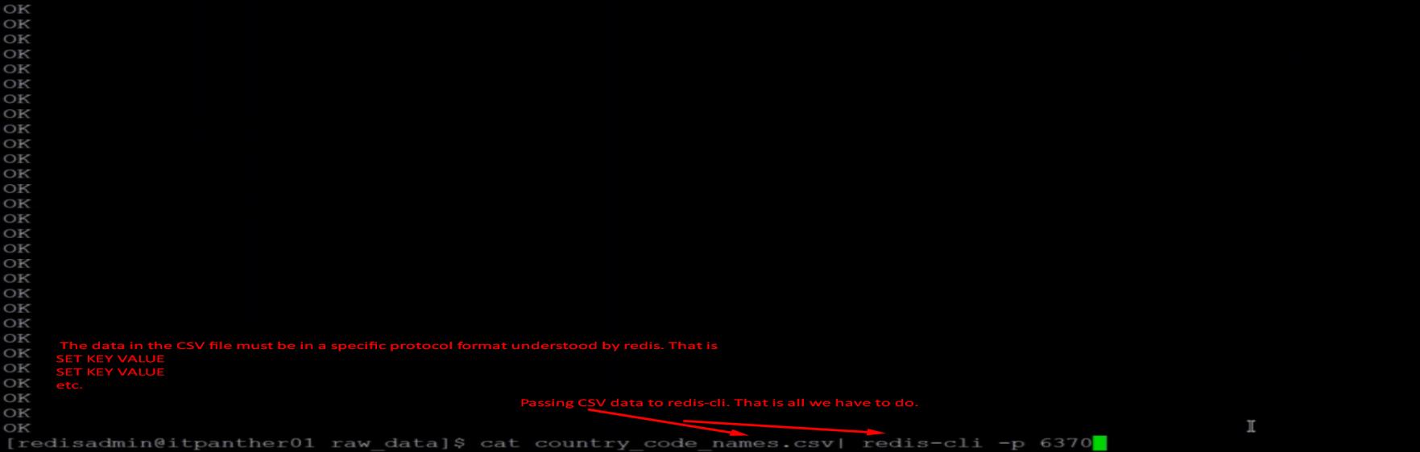
4. 